LAB 9-1 Polymorphism

Working in folder “week9”.

Program 1 overiding

1. Create a class Person following the example.

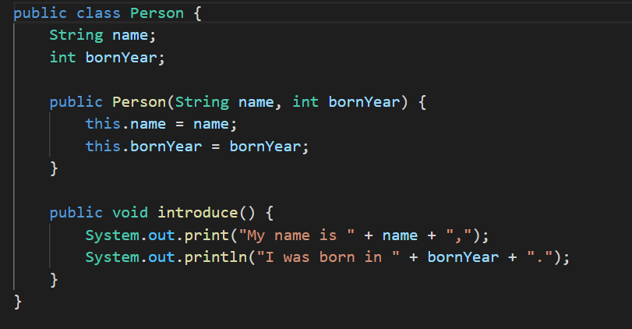

1. Create a main program

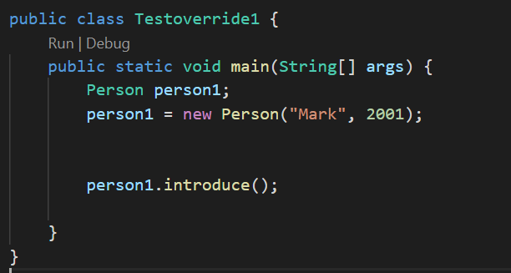

1. Compile and run the program.
2. Create a subclass name Sheriff which extented form Person class.

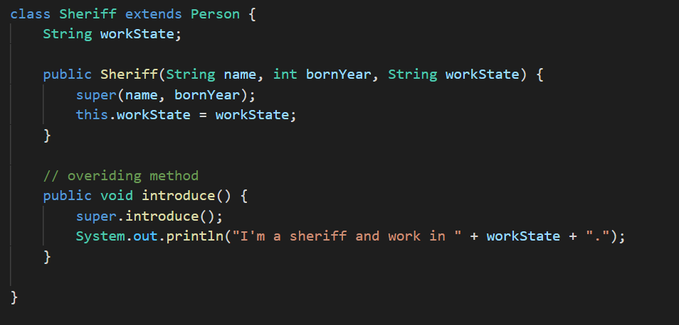

1. In the main program add a new object person2 into the program.

person2 = new Sheriff(“Mateo”,1988,”California”);

1. Use the method introduce() with the person2

Person2.introduce();

1. Compile and run the program.

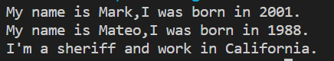

Question 1. Why the output of the program from introduce() with person1 and person2 are difference?

1. Add more object and class to the program. Use polymorphism to complete technique the output.

|  |
| --- |
| My name is Ball, I was born in 1977.  I’m a teacher and teach the students in CMU. |
| My name is Tu, I was born in 1954.  I’m a prime minister and work in Thailand. |
| My name is Messi, I was born in 1987.  I’m a football player and work in Barcelona football club |
| (add one more person from your idea) |

Program 2 toString()

1. Write the following program.

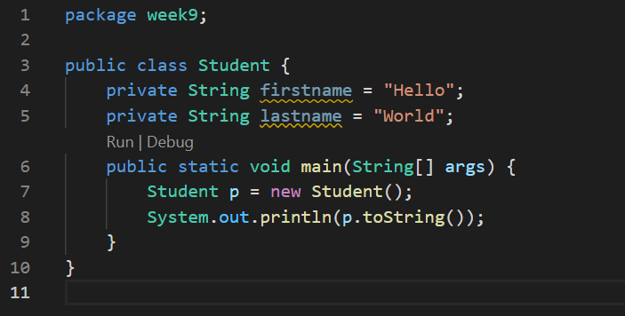

1. Compile and run the program

Question 2. What is the result of the program? **// nothing happen because we did not return toString yet.**

Question 3. Explain the result. What is the mechanism of the toString method?// when we return toString the result will display both first name and last name. So toString method work to display the result.

1. Add the overriding toString()

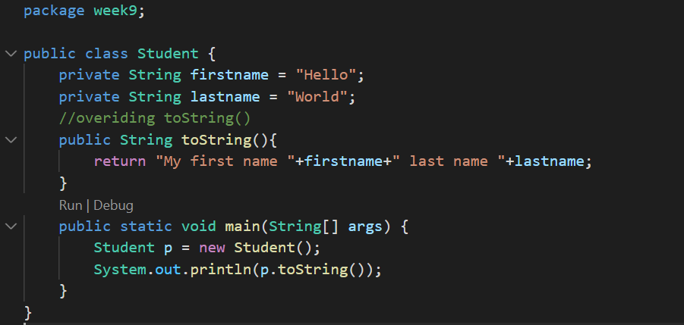

Question 4 What is the result of the program, Why?

**The result is Hello World. We represent first name is Hello and last name is World in private variables.**

1. Modify the program. Create a constructor to receive 2 Strings and set the firstname variable and lastname variable of the Student class according to the input.

**Program 3 Shape**

Create 3 classes: shape, rectangle and cube. The Rectangle class extends the Shape class and the Cube class extends the Rectangle class. Please add the necessary information (attribute and the method to all of the class.)

* When toString method of the Shape class is called, the method returns “This is a shape”.
* When toString method of the Rectangle class is called, the method returns “This is a rectangle with width as [width] and height as [height]”.
* When toString method of the Cube class is called, the method returns “This is a cube with the side of [length]”.

------------------------------------------------End of Lab------------------------------------------